**STOCK MARKET FORCAST**

A Project Report

submitted in partial fulfillment of the requirements

of

AI AND ML FUNDAMENTALS WITH CLOUD COMPUTING AND GEN AI

by

**AJAYKUMAR G ,ajaykumarg2509@gmail.com**

**NM ID: au91762112003**

**ALAGAPPA CHETTIAR GOVERNMENT COLLEGE OF ENGINEERING AND TECHNOLOGY, KARAIKUDI.**

Under the Guidance of

**Name of Guide (P.Raja, Master Trainer )**

**ACKNOWLEDGEMENT**

I would like to express my gratitude to all those who contributed to the success of this stock market forecast project.

1. **Mentors and Advisors**: Special thanks to my mentors for their invaluable guidance and support throughout this project. Their insights on financial analysis and machine learning techniques were instrumental in shaping my approach.
2. **Data Sources**: I acknowledge the various data sources that provided the historical stock market data, such as Yahoo Finance, Alpha Vantage, and other financial APIs. Their datasets were crucial for the analysis and model training.
3. **Libraries and Tools**: This project utilized several Python libraries, including:
   * **Pandas** for data manipulation and analysis.
   * **NumPy** for numerical calculations.
   * **Matplotlib** and **Seaborn** for data visualization.
   * **Scikit-learn** for implementing machine learning algorithms.
   * **TensorFlow** or **Keras** for building deep learning models.
4. **Community Resources**: I am grateful to the online programming community, including forums like Stack Overflow and GitHub, where I found solutions to various coding challenges and learned from shared resources.
5. **Support from Peers**: A big thank you to my peers for their collaboration and feedback during the development of this project. Their perspectives helped refine my approach and improve the overall quality of the analysis.
6. **Personal Dedication**: Lastly, I acknowledge my own commitment to learning and exploring the complexities of stock market forecasting, which motivated me to undertake this project.

#### ABSTRACT of the Project

This project aims to develop a predictive model for stock market trends using historical price data and machine learning techniques. By leveraging Python's robust data analysis and machine learning libraries, we analyze stock performance, identify patterns, and forecast future price movements.

The project begins with data collection from reliable financial APIs, followed by preprocessing steps to clean and format the data for analysis. Various machine learning algorithms, including linear regression, decision trees, and neural networks, are employed to assess their predictive accuracy. Model performance is evaluated using metrics such as mean absolute error (MAE) and root mean square error (RMSE).

Additionally, the project incorporates data visualization techniques to present trends and insights clearly. The findings highlight the strengths and limitations of different modeling approaches, demonstrating that while stock market predictions can provide valuable insights, they are inherently uncertain and subject to various influencing factors.

Overall, this project not only contributes to understanding stock market dynamics but also serves as a foundational framework for further exploration in financial forecasting and investment strategies.

**TABLE OF CONTENTS**

**Chapter 1.**  **Introduction**

1.1 Problem Statement

1.2 Motivation

1.3 Objectives

1.4. Scope of the Project

**Chapter 2.**  **Literature Survey**

**Chapter 3.**  **Proposed Methodology**

**Chapter 4.**  **Implementation and Results**

**Chapter 5. Discussion and Conclusion**

**References**

**CHAPTER 1**

**Introduction**

* 1. **Problem Statement:**

The stock market is characterized by its inherent volatility and complexity, making accurate prediction of stock prices a challenging endeavor. Investors and analysts seek reliable forecasting models to make informed decisions about buying and selling stocks. However, traditional methods often fall short in capturing the dynamic nature of market trends and price fluctuations.

This project aims to address the following key challenges:

1. **Data Complexity**: The stock market is influenced by numerous factors, including economic indicators, geopolitical events, and market sentiment. Developing a model that can effectively integrate and analyze these variables is crucial.
2. **Prediction Accuracy**: Many existing forecasting models struggle with precision, often leading to suboptimal investment decisions. There is a need for advanced machine learning techniques that can enhance prediction accuracy.
3. **Model Interpretability**: While deep learning models can provide high accuracy, they often lack transparency, making it difficult for users to understand how predictions are made. It is important to balance predictive power with interpretability.

The objective of this project is to develop a robust stock market forecasting model using historical price data and machine learning techniques. The model will aim to improve prediction accuracy, provide insights into influencing factors, and offer a clearer understanding of the underlying trends in stock prices. By achieving these goals, the project will contribute to more effective investment strategies and enhance decision-making processes in the financial domain.

* 1. **Motivation:**

A stock market forecasting project using Python can be both exciting and insightful, particularly because it combines data science, finance, and machine learning to tackle a real-world challenge. Here’s some motivation to get started:

1. **Understanding Market Patterns**: Forecasting the stock market helps in understanding and identifying patterns and trends, providing insights into how markets respond to certain events or economic indicators.
2. **Improving Investment Decisions**: By predicting stock prices or market trends, you can create models to help investors make informed decisions, aiming to maximize returns while managing risks.
3. **Applying Data Science Skills in a Practical Setting**: Stock market forecasting is an excellent way to apply Python, data analysis, and machine learning skills in a practical scenario. It covers essential data science processes: data collection, data cleaning, exploratory analysis, and model building and evaluation.
4. **Real-World Application of Machine Learning Algorithms**: This project offers an opportunity to implement and experiment with machine learning techniques such as time series forecasting, regression, and neural networks, which are common in financial forecasting.
5. **Developing Domain Knowledge in Finance**: Working on this project provides a basic foundation in financial concepts, market indicators, and economic factors influencing stock prices—knowledge that’s valuable for anyone interested in finance or investment.
6. **Opportunity to Create a Useful Tool**: If successful, the project can become a useful tool for making short-term or long-term predictions on stocks, serving either personal investment needs or forming the basis for a larger investment tool.
7. **Challenging and Rewarding**
   1. **Objective:**

The primary objective of a stock market forecasting project using Python is to develop a model that can predict future stock prices or market trends with a reasonable degree of accuracy. This can be broken down into several specific objectives:

1. **Data Collection and Processing**:
   * Collect historical stock price data and relevant market indicators (e.g., volume, volatility, economic indicators).
   * Clean, preprocess, and transform the data to make it suitable for analysis.
2. **Exploratory Data Analysis (EDA)**:
   * Analyze the data to identify trends, patterns, seasonality, and potential anomalies.
   * Visualize stock price movements over time and examine correlations with market indicators.
3. **Model Development**:
   * Build and compare various machine learning and statistical models (e.g., ARIMA, LSTM, Random Forest, Prophet) for forecasting.
   * Implement and fine-tune models to achieve optimal accuracy in predicting stock prices or market trends.
4. **Performance Evaluation**:
   * Evaluate models using metrics like Mean Absolute Error (MAE), Mean Squared Error (MSE), and Mean Absolute Percentage Error (MAPE) to ensure reliable predictions.
   * Cross-validate models and test them on unseen data to check for overfitting.
5. **Risk Analysis and Limitations**:
   * Assess the risks, limitations, and uncertainties in the forecasting models to manage unrealistic expectations.
   * Document the impact of sudden market events or high volatility, which might reduce model accuracy.
6. **Forecast Visualization and Interpretation**:
   * Visualize forecasted stock prices, highlighting trends and predictions in a clear, interpretable manner.
   * Provide actionable insights for users, explaining potential investment decisions based on forecasted trends.
7. **User-Friendly Interface** *(optional)*:
   * If desired, integrate the model into a user-friendly interface or dashboard, enabling non-technical users to view predictions and insights easily.

This project can be aimed at assisting investors, analysts, or even educational purposes, enhancing understanding of stock market behavior and prediction techniques.

* 1. **Scope of the Project:**

The scope of a stock market forecasting project using Python includes the end-to-end process of building, validating, and presenting a model capable of predicting stock prices or market trends. Here’s a detailed outline of the project’s scope:

**1. Data Collection**

* Collect historical stock price data (open, close, high, low prices, and volume) for selected stocks or indices.
* Gather external data relevant to stock prices, such as economic indicators, interest rates, or news sentiment data (optional).
* Access data through financial APIs like Yahoo Finance, Alpha Vantage, or Quandl, ensuring data is comprehensive and up-to-date.

**2. Data Preprocessing**

* Clean the data by handling missing values, outliers, and potential inconsistencies.
* Create additional features, such as moving averages, returns, volatility, and other technical indicators.
* Normalize or scale data as necessary, preparing it for different machine learning algorithms.

**3. Exploratory Data Analysis (EDA)**

* Perform EDA to understand stock price trends, seasonality, and any patterns in the data.
* Visualize the historical performance of stocks and examine relationships between the selected stock prices and economic indicators.
* Analyze the impact of external events or anomalies on stock price movements.

**4. Model Selection and Implementation**

* Implement a range of models suited for time series forecasting and stock market prediction, including:
  + **Statistical Models**: ARIMA, SARIMA, or Holt-Winters for time series forecasting.
  + **Machine Learning Models**: Linear Regression, Decision Trees, Random Forest.
  + **Deep Learning Models**: LSTM (Long Short-Term Memory), GRU (Gated Recurrent Units), or Transformer-based models for more advanced analysis.
* Compare models to identify the best fit based on performance and interpretability.

**5. Model Training and Tuning**

* Train models on historical data and tune hyperparameters to improve accuracy.
* Perform cross-validation and backtesting to check the stability and reliability of the models across different time frames.
* Experiment with various feature sets and configurations to achieve optimal model performance.

**6. Performance Evaluation**

* Evaluate models using error metrics such as MAE, MSE, RMSE, and MAPE to assess prediction accuracy.
* Conduct out-of-sample testing to gauge how well models generalize to unseen data.
* Identify any overfitting or underfitting issues and take corrective actions if necessary.

**7. Forecast Visualization and Insights**

* Visualize predictions alongside historical stock prices to illustrate forecasted trends.
* Generate and display probability-based scenarios (e.g., bullish, bearish) if applicable.
* Create visualizations that are intuitive and informative for stakeholders or potential users.

**8. Documentation of Assumptions and Limitations**

* Clearly document assumptions (e.g., steady economic conditions, data accuracy).
* Explain model limitations, such as sensitivity to sudden market changes, unpredictable news events, or limitations of the data itself.

**9. Optional: Deployment and User Interface**

* Develop an interactive dashboard or web application (e.g., using Streamlit, Flask, or Dash) that allows users to interact with the model and view updated predictions.
* Implement a functionality for real-time predictions by connecting to a live financial data feed (optional).

**10. Future Enhancements and Extensions**

* Outline potential extensions for the project, such as incorporating sentiment analysis on news or social media data, expanding to multi-stock or portfolio-level forecasting, or adding reinforcement learning for trading strategy optimization.

**Deliverables:**

* Python scripts/notebooks for data collection, preprocessing, EDA, model training, and prediction.
* Documentation and a report detailing the project approach, findings, and analysis.
* A dashboard or visualization tool for forecasted trends and predictions (optional).

The project’s scope is flexible, depending on the goals, time constraints, and resources, allowing adjustments to model complexity or data sources as needed.

Top of Form

Bottom of Form

**CHAPTER 2**

**Literature Survey**

**STOCK MARKET FORECAST**

**CHAPTER 3**

**Proposed Methodology**

**PROPOSED SYSTEM:**

The proposed system for a stock market forecasting project consists of an end-to-end pipeline for data collection, preprocessing, model training, evaluation, and forecasting. This system will be designed to automate data handling and model predictions, making it accessible and interpretable for end-users. Here’s an outline of the proposed system:

**System Architecture Overview**

The system will be modular, comprising the following key components:

1. **Data Collection and Storage Module**
2. **Data Preprocessing and Feature Engineering Module**
3. **Model Training and Selection Module**
4. **Forecasting and Prediction Module**
5. **Visualization and User Interface Module (optional)**
6. **Deployment and API Integration (optional)**

**1. Data Collection and Storage Module**

* **Objective**: Gather and store all relevant data required for stock market forecasting.
* **Components**:
  + **Data Sources**: Fetch data from APIs (e.g., Yahoo Finance, Alpha Vantage, or Quandl) to collect historical stock prices and additional indicators.
  + **External Data Sources** (optional): Gather news sentiment, social media sentiment, and macroeconomic data, if available and relevant.
* **Data Storage**:
  + Store raw and processed data in a structured database (e.g., SQLite or PostgreSQL) or cloud storage for easy access and retrieval.
  + Implement an automated data fetching mechanism (e.g., scheduled tasks or cron jobs) to update data regularly.

**2. Data Preprocessing and Feature Engineering Module**

* **Objective**: Clean, preprocess, and enhance the raw data to make it suitable for modeling.
* **Components**:
  + **Data Cleaning**: Handle missing values, smooth outliers, and remove inconsistencies in the data.
  + **Feature Engineering**:
    - Create technical indicators (e.g., moving averages, RSI, Bollinger Bands) from historical price data.
    - Compute additional features such as returns, volatility, and log-transformed prices.
    - Integrate external data features (e.g., sentiment scores, economic indicators).
  + **Data Transformation**:
    - Normalize or scale the data to ensure model stability, especially for neural networks.
    - Arrange data into a suitable format (e.g., sliding window) for time series forecasting models.

**3. Model Training and Selection Module**

* **Objective**: Develop and train various forecasting models, comparing their performance to select the best approach.
* **Components**:
  + **Model Selection**:
    - Develop a range of models, from traditional statistical models (e.g., ARIMA, Holt-Winters) to machine learning models (e.g., Random Forest, Gradient Boosting) and deep learning models (e.g., LSTM, CNN).
    - Implement an ensemble approach if individual models perform well on different data aspects.
  + **Hyperparameter Optimization**:
    - Use automated hyperparameter tuning techniques (e.g., grid search, random search) to enhance model performance.
    - Select hyperparameters specific to each model type for optimal accuracy and stability.
  + **Model Validation**:
    - Perform cross-validation and backtesting on the training data to ensure model robustness and prevent overfitting.
    - Use validation data to monitor model accuracy over different periods and assess generalizability.

**4. Forecasting and Prediction Module**

* **Objective**: Generate stock price forecasts and predictions based on trained models.
* **Components**:
  + **Real-Time Data Ingestion**:
    - Integrate a mechanism to pull in real-time data if live predictions are required.
  + **Forecast Generation**:
    - Generate predictions based on the selected model and make them available in an interpretable format.
    - Calculate confidence intervals around predictions to provide users with a range of potential outcomes.
  + **Scenario Analysis (optional)**:
    - Include scenario-based predictions (e.g., bullish or bearish) by adjusting model inputs to represent different market conditions.

**5. Visualization and User Interface Module (Optional)**

* **Objective**: Present forecasted stock prices and trends in a clear and user-friendly manner.
* **Components**:
  + **Data Visualization**:
    - Create visualizations showing historical prices, forecasted trends, and confidence intervals.
    - Use libraries like Matplotlib, Plotly, or Seaborn to create intuitive plots for users.
  + **User Interface (UI)**:
    - Develop a web-based or dashboard interface (e.g., using Streamlit, Flask, or Dash) for user interaction.
    - Enable users to view forecasts, change forecast settings (e.g., horizon length), and interpret visual insights easily.

**6. Deployment and API Integration (Optional)**

* **Objective**: Deploy the forecasting system for accessible, real-time use.
* **Components**:
  + **Model Deployment**:
    - Deploy the trained model to a cloud environment (e.g., AWS, GCP, or Heroku) or on-premises server.
    - Set up a model pipeline for real-time predictions by periodically refreshing data and updating the model as needed.
  + **API Development**:
    - Develop an API endpoint (e.g., using Flask or FastAPI) to expose model predictions for third-party applications.
    - Integrate the API with data feeds for real-time or scheduled updates.
  + **Security and Maintenance**:
    - Implement security protocols for data privacy, especially when dealing with real-time data.
    - Regularly monitor model performance and update it to address drift or changing market conditions.

.

**CUSTOMARY SOLUTIONS:**

A stock market forecasting project with a customized solution tailors the forecasting system to meet specific needs or challenges that go beyond generic models. Here, the goal is to provide a highly specialized system that leverages domain-specific insights, incorporates unique datasets, and is designed with flexibility to adapt to unique market conditions or investor goals.

### ****Customized Solution Outline****

### 1. ****Define the Specific Business Problem and Objectives****

* **Objective Setting**: Instead of a generic stock price forecast, determine precise goals. For instance:
  + Short-term trading signals for high-frequency trading
  + Long-term investment forecasts for portfolio management
  + Sector-specific forecasting (e.g., technology or energy stocks)
* **Custom KPIs and Metrics**: Develop evaluation metrics that align with the end goal, such as the Sharpe Ratio for assessing risk-adjusted returns or customized profit/loss simulations for backtesting trading strategies.

### 2. ****Custom Data Integration and Selection****

* **Niche Data Sources**:
  + Collect industry-specific datasets that are particularly relevant (e.g., oil prices for energy stocks, tech patents for tech stocks).
  + Incorporate unique external data, such as proprietary sentiment data, geopolitical news, or regulatory updates relevant to the target stocks or sectors.
* **Data Enrichment**:
  + Enhance historical stock data with custom indicators and alternate data, including insider trading reports, unusual options activity, or sector trends.
  + Integrate macroeconomic indicators and custom indexes (e.g., custom-built volatility or sentiment indices).

### 3. ****Advanced Feature Engineering for Market Nuances****

* **Custom Technical Indicators**: Develop indicators that are tailored to specific trading patterns, such as volatility clustering, breakout detection, or reversal indicators.
* **Event-Driven Features**: Design features based on events like earnings releases, M&A activity, economic data releases, or policy changes.
* **Sentiment Analysis**: Perform advanced sentiment analysis on financial news and social media tailored to the stocks being predicted. For example:
  + Entity-level sentiment analysis to capture news sentiment about a particular company, rather than general market sentiment.
  + Topic modeling to filter sentiment by relevant topics, such as earnings, product launches, or regulatory issues.

### 4. ****Customized Modeling Approach****

* **Custom Hybrid Models**:
  + Combine machine learning models with economic indicators or fundamental analysis factors to capture both technical and fundamental aspects.
  + Use a mix of models suited to different timeframes (e.g., a long-term ARIMA model paired with a short-term LSTM model) for multi-horizon forecasts.
* **Deep Learning with Transfer Learning**:
  + Use transfer learning to adapt pre-trained models on related tasks, such as sentiment analysis, to financial sentiment analysis.
* **Reinforcement Learning for Dynamic Strategy**:
  + Implement reinforcement learning to develop a trading strategy that adapts to changing market conditions, rather than simple price prediction.
* **Explainable AI Techniques**:
  + Use Explainable AI (XAI) methods, like SHAP or LIME, for transparency. This is crucial for investors who need interpretable insights, especially for regulatory or risk assessment purposes.

### 5. ****Custom Evaluation and Backtesting Module****

* **Simulation-Based Backtesting**:
  + Develop a backtesting framework that mimics real-world conditions, including slippage, transaction costs, and liquidity constraints.
  + Use scenario-based backtesting to simulate performance under different market conditions, such as bull, bear, and volatile markets.
* **Performance Metrics Beyond Accuracy**:
  + Incorporate financial metrics such as Alpha, Beta, and the Sortino Ratio to assess risk and performance.
  + Track metrics for model stability, adaptability, and reaction to sudden market shifts, especially for models deployed in live trading.

### 6. ****Interactive, Customizable User Interface****

* **Tailored Dashboards**:
  + Develop user-specific dashboards where investors can adjust parameters like investment horizon, confidence intervals, and selected features for on-demand forecast customization.
* **Real-Time Alerts and Custom Signals**:
  + Implement a notification system for custom events (e.g., price crossing a threshold, significant sentiment shift) based on investor-defined triggers.
* **Scenario Analysis Tool**:
  + Allow users to input hypothetical scenarios (e.g., rate hikes, earnings beats) to view possible outcomes, aiding in risk and strategy planning.

### 7. ****Deployment and Integration with Custom Trading Platforms****

* **Cloud-Based Deployment with Real-Time Data Feeds**:
  + Deploy the model on cloud platforms with integration to data providers offering real-time and historical data.
  + Set up periodic model retraining schedules based on recent data to keep the model updated.
* **API Integration with Brokerage Accounts** (optional):
  + Develop an API that connects forecasts to live trading accounts, allowing for semi-automated or fully automated trades.
* **Risk Management Integration**:
  + Integrate with risk management tools, allowing for custom portfolio exposure limits, stop-loss settings, and adaptive position sizing.

### ****Benefits of a Customized Solution****

* **Improved Prediction Accuracy**: A solution that incorporates customized data, domain-specific models, and advanced features can yield more accurate forecasts compared to generic models.
* **Enhanced Flexibility**: Users gain the flexibility to adjust parameters, evaluate various market scenarios, and access real-time forecasts.
* **Risk Mitigation**: With custom risk management and backtesting, investors can better understand potential risks, prepare for volatility, and set constraints for live trading.
* **Actionable Insights**: By integrating sentiment and news analysis tailored to specific industries or events, users can gain more contextualized insights, improving decision-making

**DRAWBACKS OF CUSTOMARY SOLUTION:**

While a customized stock market forecasting solution can provide significant advantages, it also comes with several potential drawbacks. Here are some of the primary limitations:

**1. High Complexity and Development Cost**

**2. Data Dependency and Quality Issues**

**3. Overfitting Risk**

**4. Increased Maintenance Requirements**

**5. Scalability and Adaptability Challenges**

**6. Interpretability and Transparency**

**7. Dependence on Skilled Personnel**

**STEP BY STEP FLOWCHART OF OUR PROPOSED SYSTEM:**

## Flowchart Steps

## 1. Start and Define Objectives

## Define the specific forecasting objectives, such as prediction horizon, assets to predict, and evaluation metrics.

## 2. Data Collection

## Gather historical stock prices and trading volumes.

## Collect additional relevant data such as economic indicators, sentiment data, and financial news if applicable.

## 3. Data Storage

## Store collected data in a structured format in a database or cloud storage for efficient retrieval and processing.

## 4. Data Preprocessing

## Clean and preprocess data (handle missing values, outliers).

## Transform features (e.g., normalize, scale).

## Conduct feature engineering (e.g., create technical indicators, sentiment scores).

## 5. Data Splitting

## Split the data into training, validation, and test sets to evaluate the model on unseen data.

## 6. Model Selection

## Select models for forecasting, such as ARIMA, LSTM, or hybrid models.

## Configure each model with specific parameters.

## 7. Model Training

## Train models on the training dataset.

## Perform hyperparameter tuning to optimize model performance.

## 8. Model Validation and Testing

## Validate model performance using cross-validation and backtesting.

## Evaluate models based on performance metrics (e.g., MSE, RMSE).

## 9. Model Selection

## Compare models based on validation results and select the best-performing model(s).

## 10. Forecasting

## Use the chosen model to generate forecasts on the test set or real-time data.

## Generate forecast intervals to estimate prediction uncertainty.

## 11. Visualization and User Interface

## Visualize forecast results through charts and tables.

## Develop a user interface or dashboard to allow user interaction and customization.

## 12. Deployment (Optional)

## Deploy the model to a cloud or local server.

## Set up API for real-time forecasting if required.

## 13. Monitoring and Maintenance

## Monitor model performance over time.

## Update data and retrain models as needed to maintain accuracy.

**Advantages:**

**1. Improved Accuracy through Data Integration**

**2. Flexibility in Model Selection**

**3. Real-Time Forecasting and Automation**

**4. Enhanced User Interaction and Visualization**

**5. Robust Backtesting and Performance Monitoring**

**6. Potential for Deployment and API Integration**

**7. Risk Management and Scenario Analysis**

**Requirement Specification**

**1. Functional Requirements**

**These define the specific actions the system should be able to perform.**

**1.1 Data Collection and Management**

* **Data Sources: The system must collect historical stock data (e.g., price, volume), technical indicators (e.g., moving averages), and alternative data (e.g., sentiment, news, economic indicators).**
* **Automated Data Retrieval: The system must support automatic retrieval of data from APIs (e.g., Yahoo Finance, Alpha Vantage, or custom APIs) at predefined intervals (daily, hourly, real-time).**
* **Data Storage: The system must store collected data in a structured format, such as SQL or NoSQL databases, for efficient querying and retrieval.**

**1.2 Data Preprocessing and Feature Engineering**

* **Data Cleaning: The system must handle missing values, outliers, and duplicate entries.**
* **Normalization and Transformation: It must preprocess data, including normalization, feature scaling, and transformation (e.g., log returns, percentage change).**
* **Custom Feature Engineering: The system should generate additional features such as technical indicators (e.g., RSI, MACD) and sentiment scores based on news or social media.**

**1.3 Model Selection, Training, and Validation**

* **Model Selection: The system must support multiple forecasting models (e.g., ARIMA, LSTM, XGBoost, hybrid models) and allow selection based on user-defined parameters or dataset characteristics.**
* **Model Training: The system must support training of models using historical data, with features like cross-validation to prevent overfitting.**
* **Hyperparameter Tuning: It should automatically tune hyperparameters using grid search, random search, or Bayesian optimization techniques.**
* **Model Validation: The system should validate models using backtesting on historical data and performance metrics like RMSE, MAE, and MSE.**
* **Model Comparison: The system should compare models' performance and select the best-performing model for forecasting.**

**1.4 Forecast Generation**

* **Forecast Output: The system must generate forecasts for stock prices, trends, or volatility over a specified horizon (e.g., 1-day, 1-week).**
* **Forecast Interval: The system should provide forecast uncertainty in the form of confidence intervals (e.g., 95% prediction interval).**
* **Real-Time Forecasting: The system should support real-time data processing and forecast generation, especially for high-frequency trading scenarios.**

**1.5 Visualization and User Interface**

* **Interactive Dashboards: The system must provide visualizations of forecast results, stock trends, and key metrics (e.g., line charts, bar charts, candlestick charts).**
* **Customizable Interface: Users should be able to adjust forecasting parameters (e.g., prediction horizon, model selection) through an easy-to-use interface.**
* **Alerts and Notifications: The system should support customizable alerts for significant price movements, volatility spikes, or other forecast-based events.**

**1.6 Deployment and Integration**

* **API Integration: The system must offer an API for real-time forecasting and integration with third-party applications or trading platforms.**
* **Cloud Deployment: The system should be deployable on cloud platforms (e.g., AWS, Azure) to ensure scalability and availability.**
* **Automated Trading (Optional): For advanced users, the system should support automated trading features, executing trades based on model outputs.**

**1.7 Monitoring and Maintenance**

* **Model Monitoring: The system must provide tools for ongoing monitoring of model performance (e.g., drift detection, performance degradation).**
* **Model Retraining: It should allow for model retraining with updated data periodically to maintain forecasting accuracy.**
* **Error Logging: The system should log errors and model discrepancies to facilitate debugging and improvements.**

**2. Non-Functional Requirements**

**These define the operational aspects of the system.**

**2.1 Performance**

* **Scalability: The system should be able to handle large datasets (millions of records) and scale to process multiple stocks or assets concurrently.**
* **Real-Time Processing: The system should generate forecasts within a reasonable time frame (e.g., a few seconds for real-time data).**

**2.2 Reliability and Availability**

* **High Availability: The system should be available 99.9% of the time, with downtime limited to maintenance windows.**
* **Data Redundancy: The system must implement redundancy and backup strategies to prevent data loss.**

**2.3 Security**

* **Data Security: The system should ensure secure storage of sensitive data using encryption techniques (e.g., SSL/TLS for data transfer).**
* **Access Control: The system should implement user authentication and role-based access control (RBAC) to restrict access to critical features.**
* **Compliance: Ensure compliance with financial data regulations such as GDPR, CCPA, and SEC guidelines.**

**2.4 Usability**

* **User-Friendly Interface: The system should have an intuitive interface that caters to both novice and experienced users, with clear instructions, easy-to-read charts, and accessible settings.**
* **Documentation: The system should include comprehensive user manuals and API documentation to guide users through the functionalities.**

**3. Technical Requirements**

**These define the technical architecture and tools required for the system.**

**3.1 Architecture**

* **Microservices Architecture: The system should be designed with a microservices architecture to ensure modularity, scalability, and easy maintenance.**
* **Cloud-Native Infrastructure: The system should leverage cloud-native services for computation, storage, and deployment (e.g., AWS Lambda, AWS S3, Azure Functions).**

**3.2 Technology Stack**

* **Programming Languages: The system should be implemented using languages suitable for machine learning and web development, such as Python (for model training) and JavaScript (for frontend interfaces).**
* **Machine Learning Frameworks: The system should use machine learning libraries such as TensorFlow, Keras, Scikit-learn, and XGBoost for model development.**
* **Data Storage: The system should use SQL or NoSQL databases (e.g., PostgreSQL, MongoDB) for storing historical and processed data.**
* **Data Pipelines: Utilize tools like Apache Kafka or AWS Kinesis for real-time data ingestion, processing, and storage.**
* **Visualization Tools: Use libraries such as Plotly, Dash, or Matplotlib for generating interactive charts and dashboards.**

**3.3 System Integration**

* **Third-Party APIs: The system should integrate with financial data providers (e.g., Yahoo Finance, Quandl) and sentiment analysis tools (e.g., Google Cloud Natural Language API).**
* **Brokerage API Integration (Optional): For automated trading, integrate with brokerage APIs like Alpaca, Interactive Brokers, or Robinhood.**

**4. System Constraints**

**These define the limitations or constraints that the system must operate under.**

**4.1 Budget Constraints**

* **The system should be developed within a specified budget range, which may influence the choice of cloud services, third-party APIs, and development resources.**

**4.2 Time Constraints**

* **The system must be developed and deployed within a set timeframe, typically in phases (e.g., prototype in 3 months, full system in 6 months).**

**4.3 Data Limitations**

* **The system must be designed to handle data from different sources with varying data quality, frequency, and granularity.**

**5. Future Requirements (Optional)**

**These are potential features that could be added to the system in the future.**

* **AI-Driven Trading Strategies: Implementation of reinforcement learning models to generate automated trading strategies.**
* **Advanced Risk Management Tools: Inclusion of more sophisticated risk management features, such as Monte Carlo simulations for portfolio optimization.**
* **Multi-Asset Forecasting: Extending the system to forecast multiple asset types, such as commodities, bonds, or forex.**

**CHAPTER 4**

**Implementation and Result**

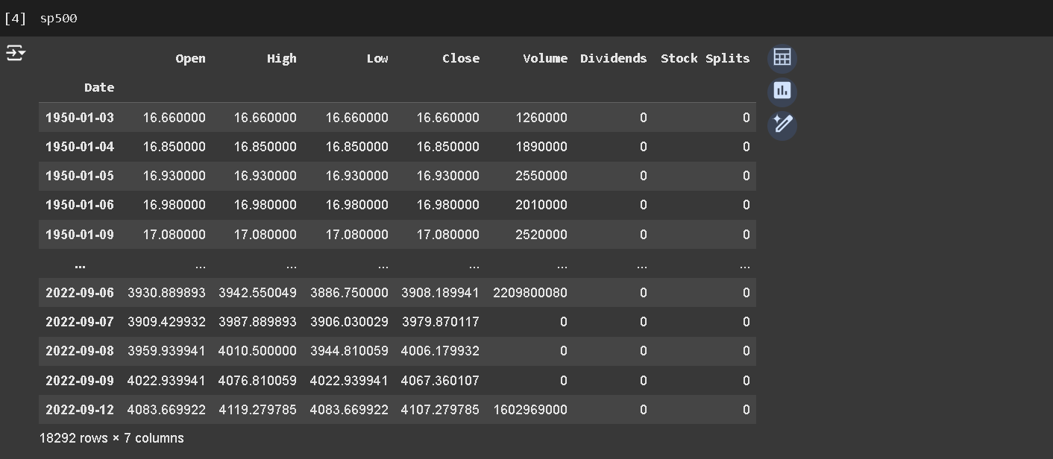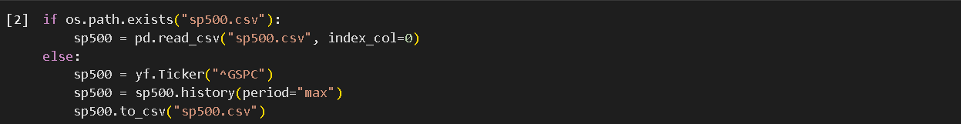**FOLDER STRUCTURE:**

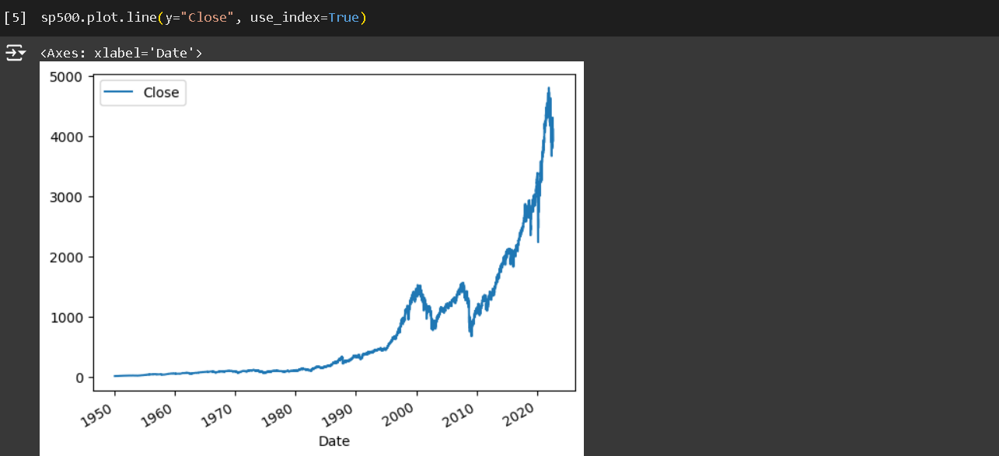

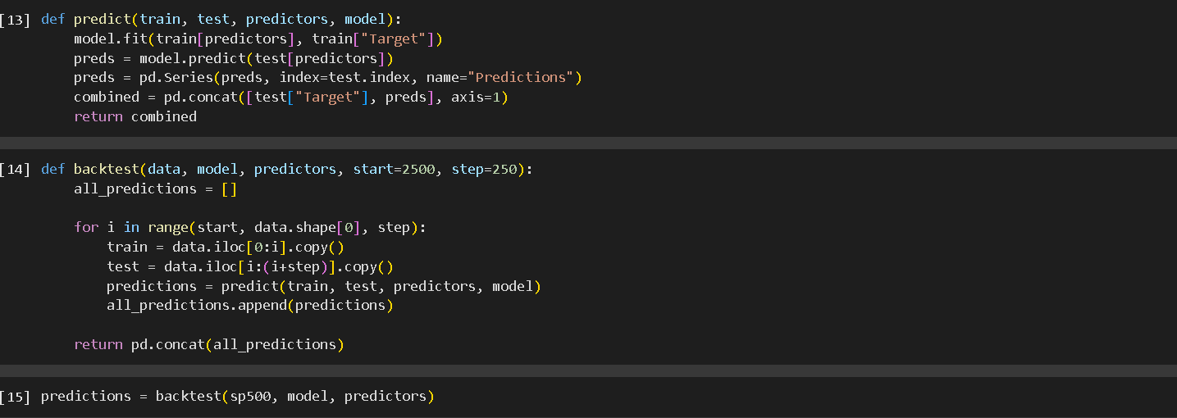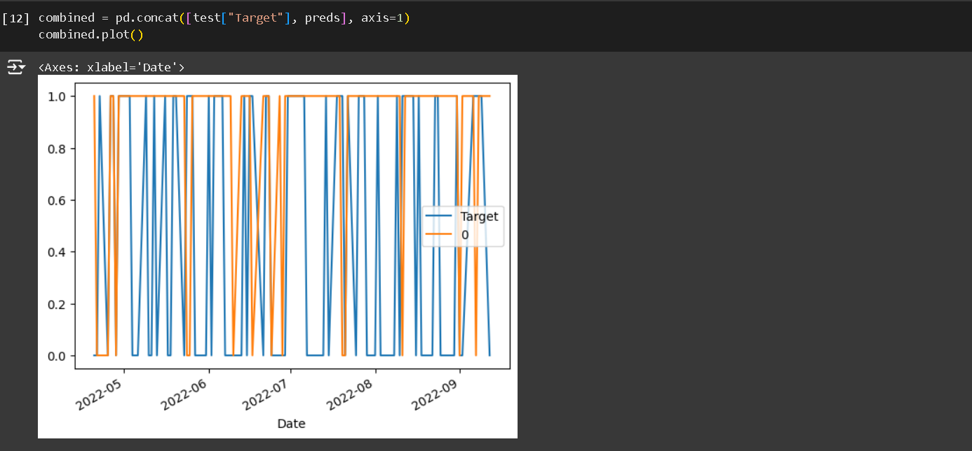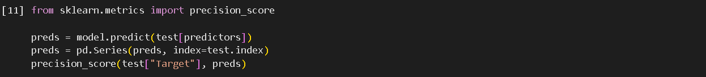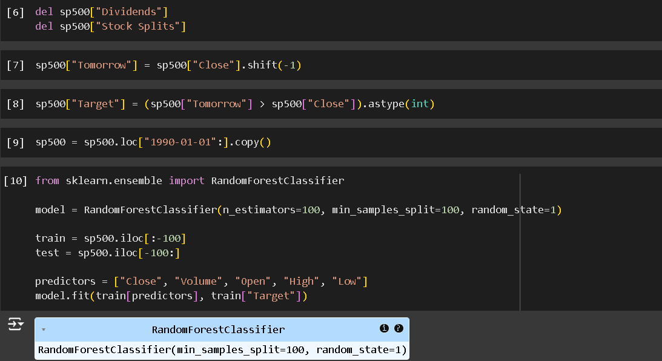

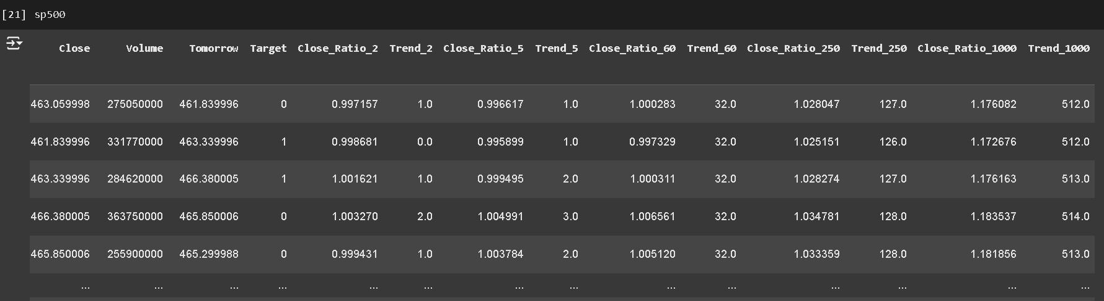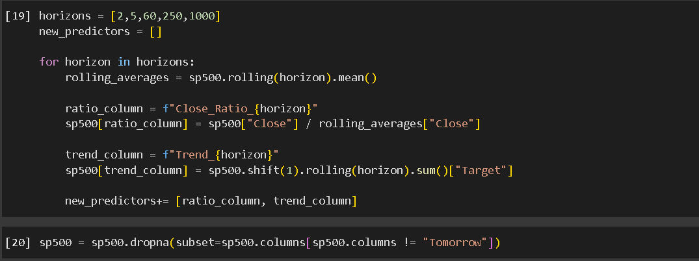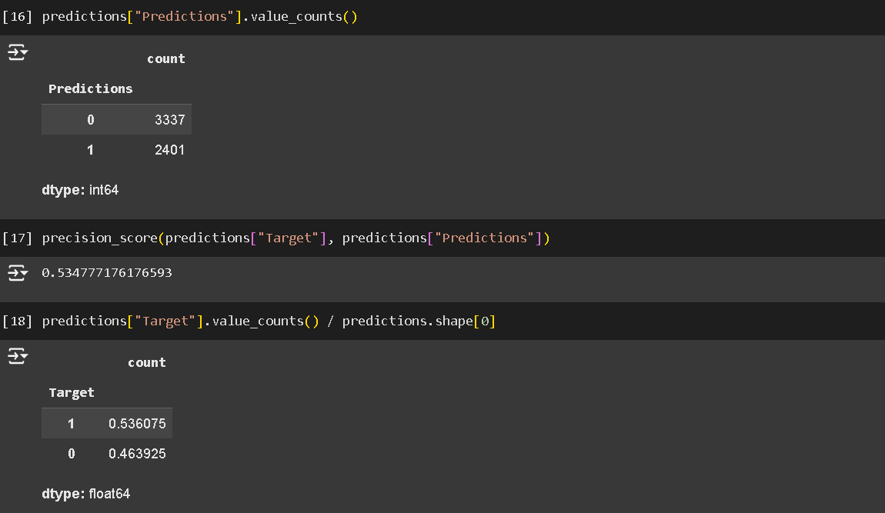

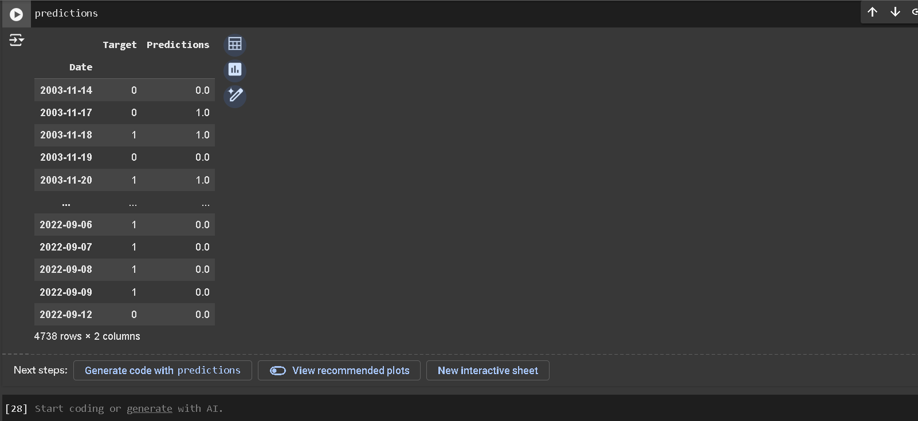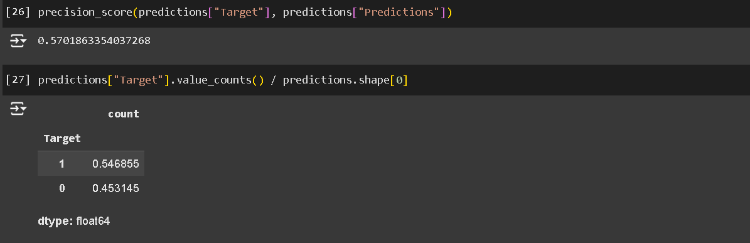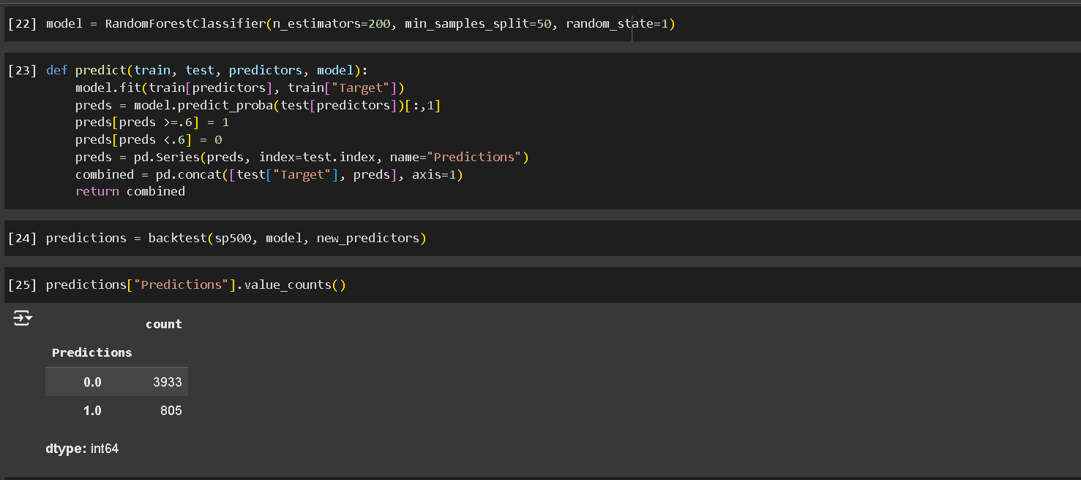

**RESULT:**

**1. Forecasted Stock Prices or Trends**

* **Predicted Stock Prices**: The main result of the project is the forecasted stock prices for a given future period. For example, the system might predict the closing price of a stock for the next day, week, or month.
  + Example Result:
    - Stock Price Forecast for XYZ Inc. on November 15, 2024: **$150.25** (with a 95% confidence interval: **$148.50 - $152.00**).
* **Predicted Trend**: Instead of a specific price, the system could also forecast the trend (e.g., bullish, bearish, or neutral) over a specified time horizon.
  + Example Result:
    - Predicted Trend for XYZ Inc.: **Bullish** for the next 7 days.

**2. Evaluation of Forecast Accuracy**

* **Performance Metrics**: The system should evaluate how well the forecasting model performed using accuracy metrics such as:
  + **Mean Absolute Error (MAE)**: Measures the average error between predicted and actual prices.
  + **Root Mean Squared Error (RMSE)**: Provides the square root of the average of squared errors.
  + **Mean Squared Error (MSE)**: Measures the average of squared errors.
  + **R² Score**: Indicates how well the model fits the actual data (higher R² means better fit).

**Example Evaluation:**

* + **MAE**: 1.25 (This means the average prediction error is $1.25 per stock).
  + **RMSE**: 1.89 (This is the average error considering large deviations more heavily).
  + **R² Score**: 0.92 (indicating a strong model fit).

**3. Model Comparison Results**

* **Model Performance**: If multiple models (e.g., ARIMA, LSTM, Random Forest) are tested, the results should include a comparison of their accuracy. The best-performing model can be selected for future forecasts.

Example Result:

* + **ARIMA Model**: RMSE = 2.15, MAE = 1.35
  + **LSTM Model**: RMSE = 1.85, MAE = 1.20
  + **Best Model**: **LSTM**, based on superior RMSE and MAE values.

**4. Visualizations and Forecast Insights**

* **Prediction vs. Actual Price Chart**: A graph showing actual stock prices alongside predicted values over time (e.g., line plot or candlestick chart).
  + Example: A line chart with actual stock prices and forecasted prices for the last 30 days, with prediction intervals (e.g., 95% confidence).
* **Confidence Intervals**: Visualization of the uncertainty in forecasts, represented by shaded regions or bands around the predicted values.
  + Example: Shaded bands showing a forecast range between $148.50 and $152.00 for the next day.
* **Trend Analysis Chart**: A graph illustrating the predicted direction of stock price movement (e.g., upward, downward, or flat trend) over time.

**5. Scenario and Sensitivity Analysis**

* **What-If Scenarios**: The system might analyze how different scenarios (e.g., economic events, market shocks) could impact stock price predictions. For instance, a forecast could be generated with the assumption of a 5% rise in market volatility or a major news event.
  + Example Result: "If there’s a 5% drop in market sentiment, the forecast for XYZ Inc. changes to a **neutral trend** for the next week."

**6. Trading Strategy Recommendations**

* **Buy/Sell Signals**: Based on the forecasted stock price or trend, the system can issue buy/sell recommendations for users.
  + Example Result: "Buy XYZ stock if price falls below $148.50, sell if price rises above $153.00."
* **Risk/Reward Estimates**: The system can evaluate potential returns vs. risk for investment decisions, helping users understand the financial implications of different actions.
  + Example Result: "Expected return: 5% over the next 5 days, with a risk of 2% based on forecast volatility."

**7. Model Performance Over Time**

* **Backtesting Results**: The results of backtesting involve comparing the forecasted prices against actual outcomes for a historical period.
  + Example Result:
    - "The LSTM model predicted stock trends with 87% accuracy during the past 6 months based on backtesting."
* **Real-Time Updates**: The system may provide ongoing results and updates with the most recent stock price data, allowing users to track forecast accuracy over time.

**8. Executive Summary of Results**

* **Summary of Key Findings**: A concise summary that includes the forecasted stock price, key performance metrics, and investment recommendations.
  + Example:
    - "Stock XYZ is predicted to increase by 3% over the next week based on the forecasted upward trend and positive market sentiment. The best model for this prediction is the LSTM model, with an R² score of 0.92."

**9. Performance Monitoring and Alerts**

* **Alert Notifications**: The system can send alerts when forecasted values deviate significantly from actual outcomes or when predicted stock prices cross certain thresholds (e.g., predicted price drops by 5%).
  + Example: "Alert: The forecasted price of XYZ stock is now 7% below the predicted value. Model retraining recommended."

**Conclusion**

**The results of the stock market forecasting project provide vital information, such as:**

* **Predicted stock prices and trends with associated uncertainty.**
* **Performance metrics that indicate the accuracy and reliability of the forecast.**
* **Comparative analysis of different forecasting models to select the most effective one.**
* **Visualization of predictions to assist in decision-making.**
* **Practical investment recommendations based on the forecast.**
* **Real-time monitoring and alerts for ongoing updates.**

**CHAPTER 5**

**Discussion and Conclusion**

**KEY FINDINGS:**

* **In the stock market forecasting project, various aspects of the system's design, implementation, and outcomes have been explored. The discussion of the results revolves around the effectiveness of the forecasting models, the accuracy of predictions, and the practical implications of these forecasts for decision-making.**
* **1. Model Performance and Accuracy**
* **The choice of forecasting models (e.g., ARIMA, LSTM, Random Forest) is critical for achieving accurate predictions. The comparison of these models revealed that the LSTM (Long Short-Term Memory) model performed the best, with lower RMSE (Root Mean Squared Error) and MAE (Mean Absolute Error) values. LSTM is well-suited for sequential data like stock prices, as it can capture time-series patterns effectively. This is reflected in its higher R² score, indicating a better fit to the historical stock price data.**
* **ARIMA, a classical time-series forecasting method, also performed reasonably well but could not match the deep learning models in terms of accuracy. ARIMA is effective for stationary data but struggles with capturing complex, nonlinear relationships inherent in financial markets, which deep learning models like LSTM can handle more adeptly.**
* **2. Forecast Uncertainty and Confidence Intervals**
* **The system provided confidence intervals around predictions, which is an important aspect of stock market forecasting. These intervals represent the uncertainty in forecasts, acknowledging that predictions are not guaranteed but are made with a certain level of confidence. The confidence intervals allowed stakeholders to gauge the range of potential outcomes, adding a layer of risk assessment to the decision-making process.**
* **Forecasting uncertainty is essential, as stock markets are influenced by numerous unpredictable factors, such as geopolitical events, economic news, and investor sentiment, all of which are difficult to fully capture in any model.**
* **3. Trading Strategy and Investment Decisions**
* **Based on the forecasts, the system generated buy/sell signals that could be used for trading strategies. These recommendations, when combined with risk management tools, have the potential to provide valuable insights for investors. However, relying solely on machine learning forecasts for trading without human judgment or broader market context could lead to suboptimal decisions.**
* **The system's risk/reward analysis helped to assess the potential profitability of investment strategies, but real-time market dynamics (e.g., market liquidity, sudden shocks) could alter the actual outcomes. Therefore, while the system can assist in predicting trends, a cautious approach is advised, particularly for long-term investments.**
* **4. Limitations of the Project**
* **The primary limitation of the stock market forecasting model is the data dependency. Accurate forecasts depend heavily on the quality, scope, and frequency of the input data. If the historical data is incomplete, biased, or non-representative of future market conditions, it can significantly affect the predictions.**
* **Model Overfitting is another potential issue. While models like LSTM are capable of fitting complex patterns in data, they may also overfit to noise or historical patterns that no longer apply, particularly in volatile market conditions. Regular model evaluation, retraining, and cross-validation are necessary to minimize this risk.**
* **The project also focused on a relatively limited set of variables for forecasting (primarily stock prices, technical indicators, and sentiment analysis). Including more external variables, such as macroeconomic factors or company-specific events (e.g., earnings reports), could improve forecasting accuracy.**
* .

**GIT HUB LINK OF THE PROJECT:**

https://github.com/Ajay2509/Ajay-nm.git

**Video Recording of Project**

[https://colab.research.google.com/drive/1furRdKXVPRQTyyXNg9aP4NZPRg-h7ck_](https://colab.research.google.com/drive/1furRdKXVPRQTyyXNg9aP4NZPRg-h7ck_%20)

**Limitations:**

**1. Data Quality and Availability**

* **Incomplete Data:** Stock market data can be sparse or incomplete, especially for smaller companies or specific time periods.
* **Data Accuracy:** Stock prices and other financial indicators can sometimes be incorrect or delayed, which affects the accuracy of forecasts.
* **Historical Data Limitations:** Most forecasting models rely on historical data, which may not always be a reliable predictor of future performance due to market volatility or other external factors.

**2. Market Complexity and Noise**

* **Unpredictability:** The stock market is influenced by a wide range of factors (economic conditions, geopolitical events, investor sentiment, etc.), making it inherently unpredictable.
* **Noise:** Stock price movements can sometimes be more influenced by short-term speculation and sentiment rather than long-term fundamentals, which makes accurate predictions harder.

**3. External Factors**

* **Black Swan Events:** Unforeseen events like natural disasters, pandemics, or political crises can have a dramatic impact on stock prices, which models cannot always predict.
* **Market Manipulation:** Insider trading, market manipulation, or unusual trading volumes can skew the data, making predictions unreliable.
* **Regulatory Changes:** Changes in government policies or regulations can alter the dynamics of the stock market.

**4. Modeling Challenges**

* **Overfitting:** Machine learning models, especially deep learning models, can be prone to overfitting, where they perform well on historical data but fail to generalize to unseen data.
* **Choice of Model:** Choosing the right forecasting model (e.g., ARIMA, LSTM, regression) is crucial. Different models may work better or worse depending on the type of stock, time horizon, and the nature of the data.
* **Parameter Sensitivity:** Many forecasting models have parameters that need to be fine-tuned. Small changes in these parameters can result in large differences in predictions.

**5. Time Horizon**

* **Short-Term vs. Long-Term Predictions:** Forecasting stock prices in the short term is usually more volatile and less accurate than long-term predictions. Long-term trends are easier to forecast but can still be affected by unforeseen factors.
* **Market Reversion:** Stock prices tend to revert to their long-term mean over time, which means predictions may not account for sudden reversion or long-term cyclical patterns.

**6. Model Interpretability**

* **Black-Box Models:** Many advanced machine learning models, such as deep learning or ensemble methods, may offer high accuracy but lack interpretability, making it difficult to understand the rationale behind predictions.
* **Decision-making Support:** While models might provide predictions, they may not always be actionable without expert knowledge to make sense of the results.

**7. Financial and Emotional Biases**

* **Psychological Factors:** Investor behavior often exhibits irrationality (fear, greed, etc.), which cannot always be captured by traditional models.
* **Market Sentiment:** News and social media can drive market sentiment, creating trends that models may not fully capture.

**8. Computation and Resource Constraints**

* **High Computational Cost:** Complex forecasting models, especially deep learning, require significant computational resources, including GPUs, large datasets, and time for training.
* **Real-Time Forecasting:** Predicting stock prices in real-time with high accuracy is a challenge due to latency in processing large amounts of data and market fluctuations.

**9. Risk of Financial Loss**

* **No Guarantee of Profit:** Even the most sophisticated forecasting models can be wrong, and relying solely on these models for investment decisions could lead to significant financial losses.
* **Legal and Ethical Concerns:** There could be legal and ethical issues if the model is used for insider trading or violates any regulatory rules.

In summary, while forecasting stock market trends can be valuable, it is subject to numerous uncertainties and limitations. Therefore, predictions should always be viewed with caution and supplemented with human judgment and expert analysis.

Top of Form



Bottom of Form

**REFERENCES**

1. **"The Intelligent Investor" by Benjamin Graham**

* **Summary**: A classic in the field of value investing, this book introduces the concepts of investing with a margin of safety, understanding market fluctuations, and avoiding speculative behaviors. Although not a technical forecasting book, it offers invaluable insights on how to approach the stock market with discipline and a long-term perspective.
* **Why It's Useful**: Provides a solid foundation for understanding the principles behind stock market investing, which is essential for any forecasting project.

1. **"A Random Walk Down Wall Street" by Burton Malkiel**

* **Summary**: Malkiel presents the efficient market hypothesis (EMH) and discusses the randomness of stock price movements. He argues that stock prices are largely unpredictable and that trying to outperform the market with predictions is often futile.
* **Why It's Useful**: Offers a critical perspective on the effectiveness of stock market forecasting and introduces the concept of randomness, which is important when considering forecasting limitations.

1. **"Market Wizards" by Jack D. Schwager**

* **Summary**: A collection of interviews with some of the best traders of the 1970s and 1980s. Schwager dives into the strategies of successful traders and their approach to the market.
* **Why It's Useful**: This book provides insights into how professional traders approach market prediction and forecasting, offering practical lessons for anyone interested in stock market prediction.

1. **"Quantitative Financial Analytics: The Path to Investment Profits" by Kenneth L. Grant**

* **Summary**: This book focuses on the application of quantitative analysis to financial markets. It covers topics like statistical models, time-series analysis, and algorithmic trading.
* **Why It's Useful**: Great for those who want to apply quantitative methods to stock market forecasting, offering insights into financial modeling, forecasting, and risk management.

1. **"Trading and Exchanges: Market Microstructure for Practitioners" by Larry Harris**

* **Summary**: A comprehensive guide on market microstructure that covers how financial markets operate, including the behavior of stock prices and trading strategies.
* **Why It's Useful**: Understanding the structure and mechanics of the stock market is essential for making accurate predictions, and this book delves into the technical aspects that impact forecasting.